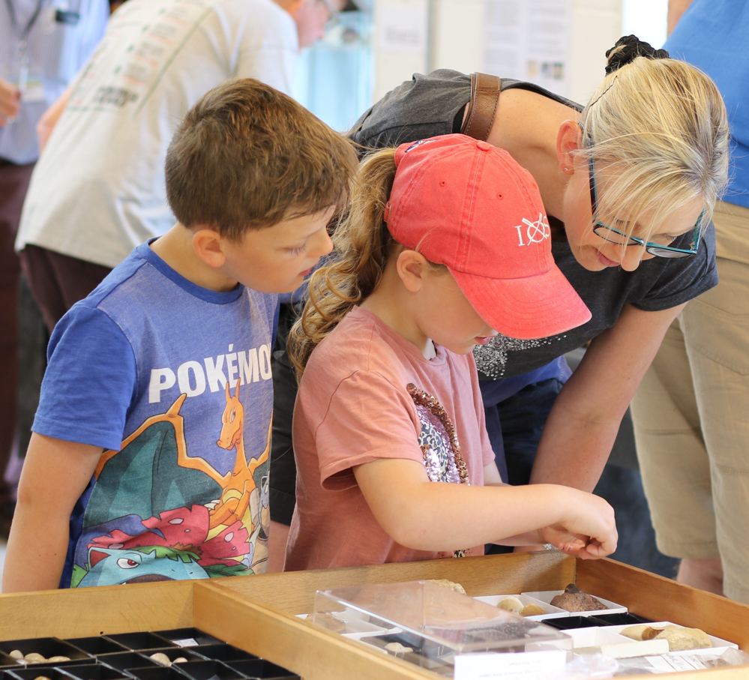
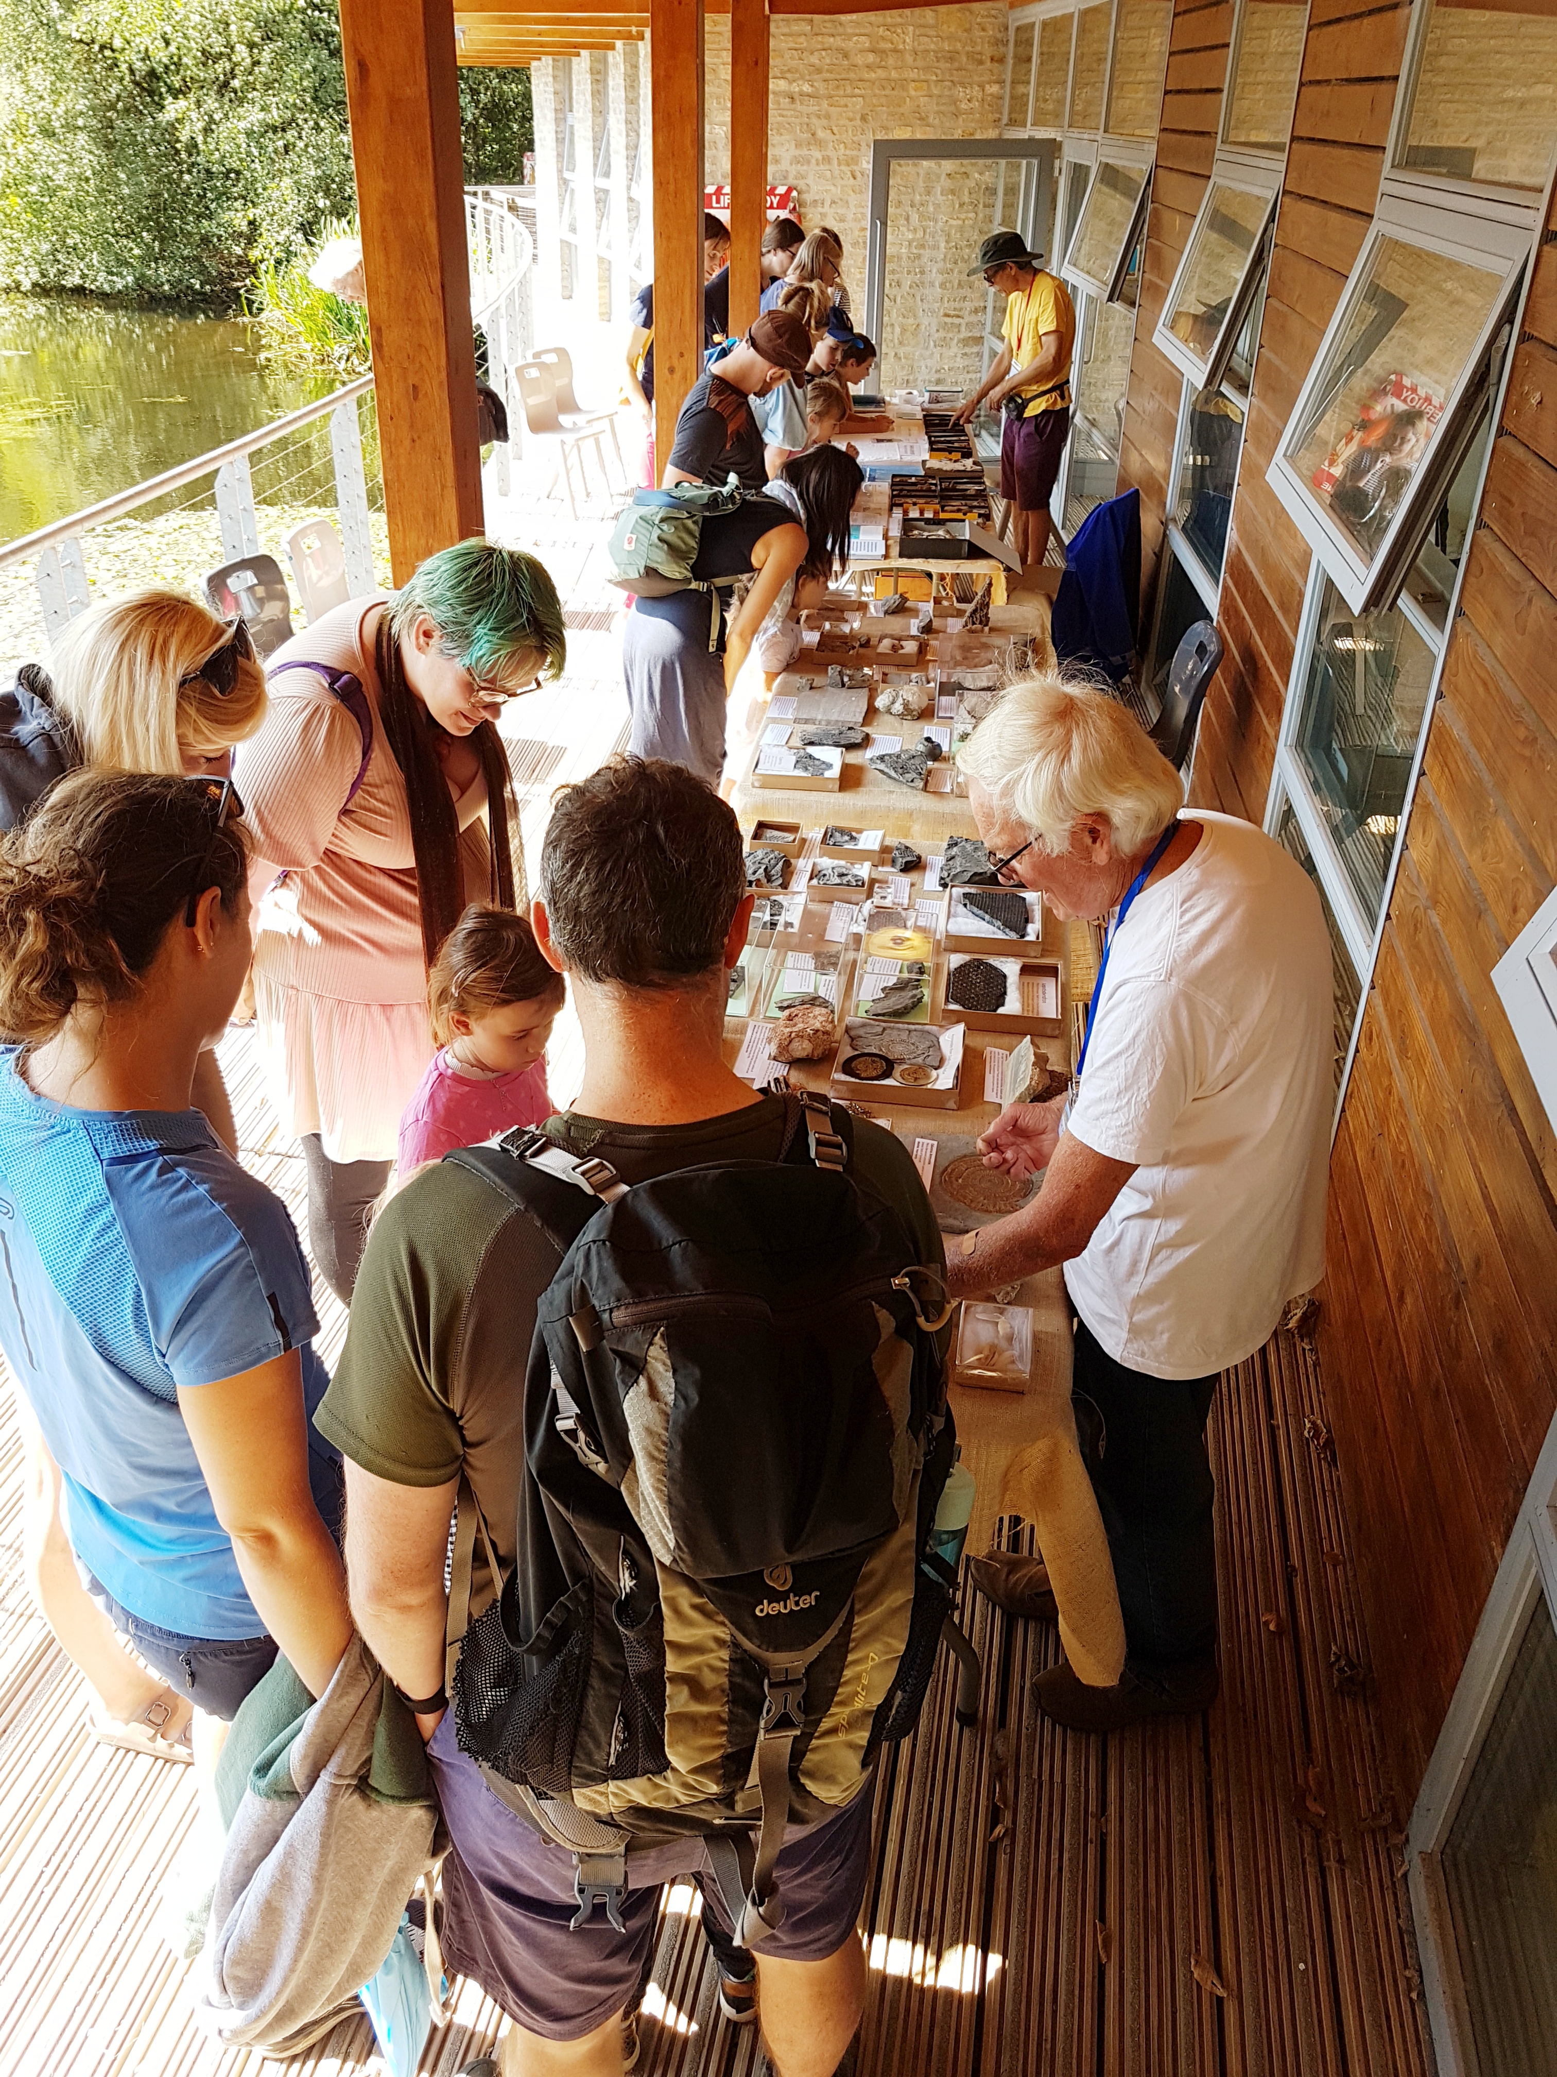
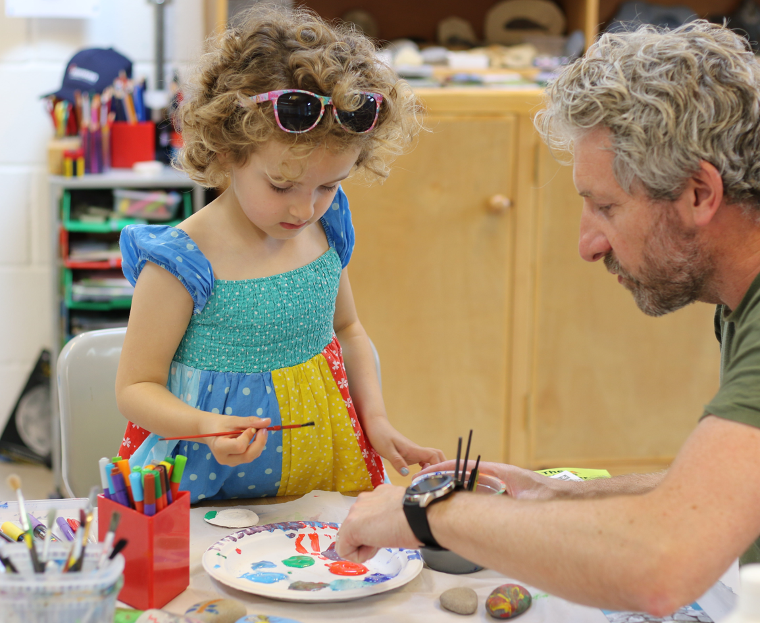

  - Mini Museum & Open Day
  - Somerset Earth Science Centre
Saturday 17th February 11am-3.30pm
Free entry, please reverse park in top of car park, lakeside path to SESC
Come and see our fascinating collection of Mendip Rocks, Minerals and Fossils
Bring in your own fossils and rocks for identification by experts
Get creative with our fossil arts and crafts activities
Outdoor geo time trail and quiz
Light refreshments, sit by the lake with tea and cake
Fossils and minerals available to purchase
Bring wellies for the outside trail (sorry no dogs).

Somerset Earth Science Centre, Moons Hill Quarry
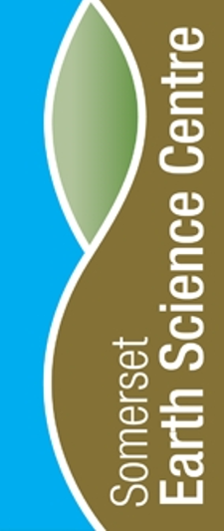
Stoke St Michael, BA3 5JU.
www.earthsciencecentre.org.uk

