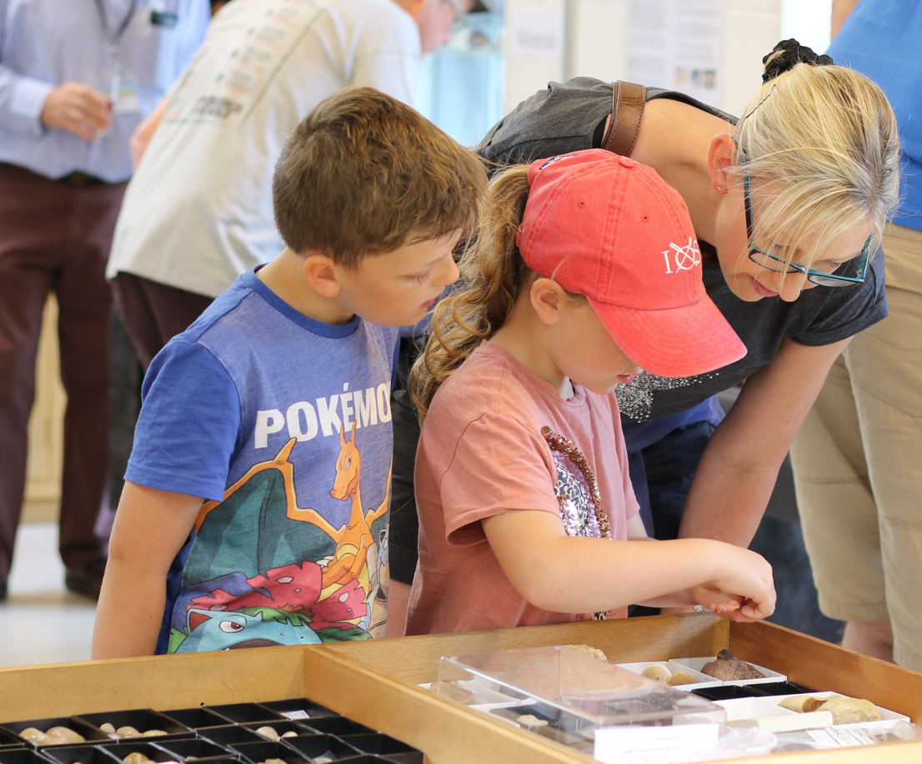
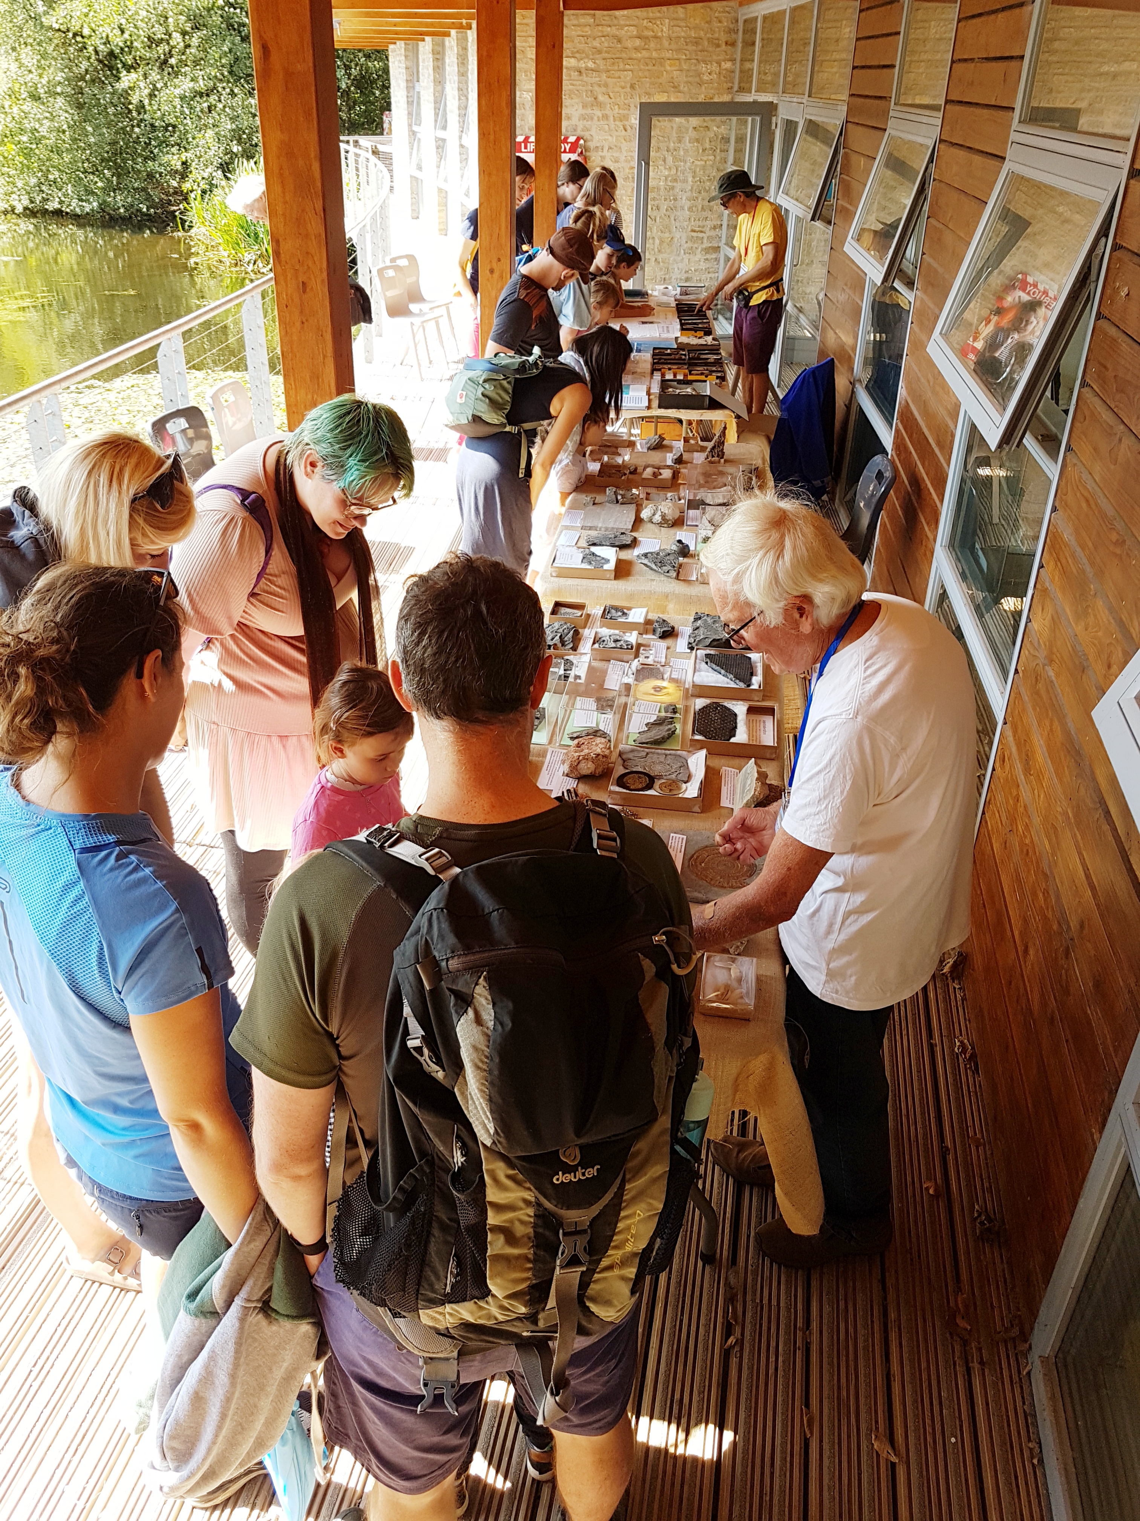


  - Mini Museum & Mary Anning Exhibition Open Day
  - Somerset Earth Science Centre
Saturday 16th August 11am-3.30pm
View our fascinating collection of Mendip Rocks, Minerals and Fossils
Bring in your own fossils and rocks to show our experts
Get creative with our fossil arts and crafts
Outdoor geo time quiz trail
Light refreshments
Fossils and minerals available to purchase
Free entry, please reverse park in top of car park, follow lakeside path to SESC
Somerset Earth Science Centre, Moons Hill Quarry
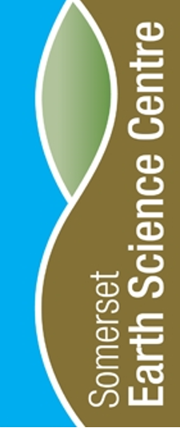
Stoke St Michael, BA3 5JU.
www.earthsciencecentre.org.uk

